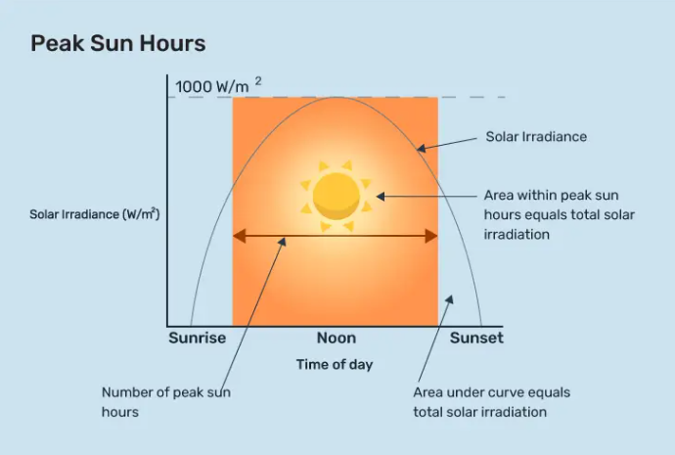

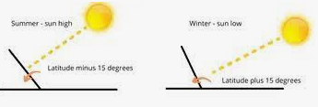

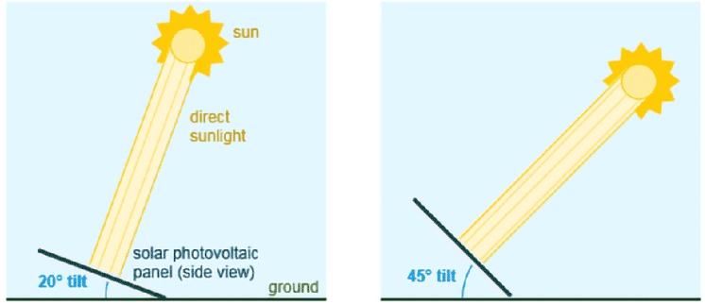

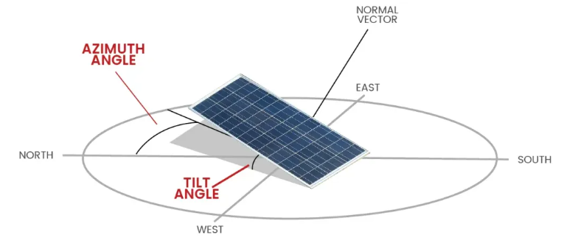

Solar Position Calculations: PVLIB can calculate the position of the sun in the sky for a given location, date, and time.

Irradiance Modeling: PVLIB includes several models for calculating the solar irradiance on a PV module or array, based on weather data and other inputs.

PV Module Modeling: PVLIB includes several models for simulating the electrical performance of PV modules, including the single diode model and the PVsyst model.

Inverter Modeling: PVLIB includes models for simulating the behavior of different types of inverters, including string inverters, central inverters, and microinverters.

Performance Modeling: PVLIB can simulate the performance of a PV system over time, taking into account changes in weather conditions, shading, and other factors.

Data Analysis: PVLIB includes tools for analyzing PV system data, including functions for calculating energy yield, efficiency, and other performance metrics.

Visualization: PVLIB includes tools for creating visualizations of PV system performance, including plots of irradiance and temperature data, and time-series plots of system performance metrics.

* US/Pacific
* US/Mountain
* US/Central
* US/Eastern
* UTC
* Europe/London
* Europe/Paris
* Asia/Tokyo
* Australia/Sydney